**Department of Extension Family and Consumer Sciences**

**Quarterly Newsletter**

**JULY 2015**

* **Detoxing: Fad or Fact?**
* **How Safe is Your Lipstick?**
* **The Truth about Dietary Supplements**



**Invited Contributor**

* **Sharpening your Crayons**

**Detoxing: Fad or Fact?**Sonja Koukel, PhD  
Community & Environmental Health Specialist

Internet websites and social media sites are all abuzz with the concept of detoxing. Recipes abound for cleansing waters, and the best fruits and vegetables for eliminating toxic wastes from our bodies.

Detoxing is touted for weight loss, age reversal, body cleansing, increasing energy levels, and stopping disease through a modified diet. According to a spokeswoman for the Academy of Nutrition and Dietetics (Orenstein, 2015) “There is no scientific evidence that “detox” (short for benefits.”



If you are set on trying a detox diet, there are plenty of articles and sources that will support your decision. However, where and from whom you get information on the Internet is extremely important.

* Are you being sold a product (commercial sites)?
* Is the information from a trusted, reliable and reputable source?
* Is there a posted disclaimer, such as: *[Organization] does not provide medical advice, diagnosis or treatment*. Unless it’s a government site, such as the CDC (the nation’s health protection agency), look for these disclaimers.

How many of us take the time to investigate the source instead of going blindly forth on the recommendation of family, friends or social media contacts? The results of which can have negative effects on our health and general well-being. When considering a detox plan or any medical advice found on the Internet, always seek the advice of your medical provider.

Unfortunately, and in contrast to the detoxing/cleansing claims, there is no quick fix to weight loss and the jury is still out on whether our body’s natural detoxing system (i.e., liver, skin, urinary system, and gastrointestinal tract) needs assistance. Experts stress that it’s not necessary to go on special diets to clean our system as our bodies naturally cleanse through sweat, urine and feces (Orenstein, 2015). Here, the evidence-based research holds true: Eat a diet high in fiber, drink lots of clean water, and avoid packaged and processed foods to keep your body working at its best.

An excellent way to reduce your body’s exposure to toxins is to limit exposure from topical applications. According to the Environmental Working Group ([www.ewg.org](http://www.ewg.org)), individuals use 9 personal care products on a daily basis containing a total of about 126 unique ingredients. The average personal care product contains about 12 chemicals with more than one-third of all personal care products containing at least one ingredient linked to cancer (Chemicals of Concern, 2015). Learn about a few of the top ingredients and contaminants to avoid by visiting the Campaign for Safe Cosmetics website at <http://sc-dev.rootid.in/get-the-facts/chemicals-of-concern/>

One step you can take today is to read the ingredient lists on personal care products. Major chemicals you can reduce or eliminate altogether are the **parabens** found in creams, lotions, cosmetics, underarm deodorants and shampoos. Parabens may be identified with the prefixes **Ethyl, Methyl, Butyl or Propyl**. The health risks associated with parabens include weight gain and breast cancer.

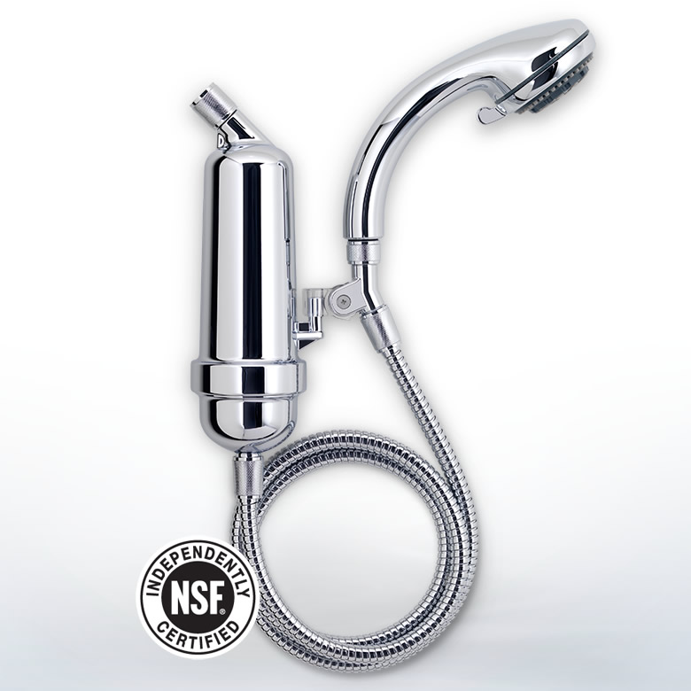

Water filtration is another good, inexpensive solution. According to a Mercola

article (2011), “…the shower filter is the most important product to buy for

water filtration, even more important than filtering your tap water.” The

reasoning behind this is that the skin and lungs absorb many more toxins

than those ingested through drinking water alone.

In conclusion, a word to the wise – instead of risking your health with detoxing, engage in good health practices. Eat a nutritious diet, drink plenty of clean water, and exercise. Then, take it a step further by being an educated consumer - read ingredient lists on personal care products to reduce chemical exposure through the skin.

Resources:

Centers for Disease Control and Prevention (CDC). *Mission*. Available at http://www.cdc.gov/about/organization/mission.htm

Mercola (2011, January). *The Quickest, Easiest Way to Help Detoxify Your Body.* Available at

<http://articles.mercola.com/sites/articles/archive/2011/01/26/whole-house-water-filtration.aspx>

Orenstein, B. W. (2015, April). *Cleansing and Detox Diets.* Available at <http://www.medicinenet.com/cleansing_and_detox_diets/article.htm#cleansing_and_detox_diets_introduction>

Smith, S. (2003, August). *Detox diets: health regimen or latest fad?* Available at <http://www.cnn.com/2003/HEALTH/diet.fitness/08/01/body.detox/>

**How Safe is Your Lipstick?**Sonja Koukel, PhD   
Community & Environmental Health Specialist

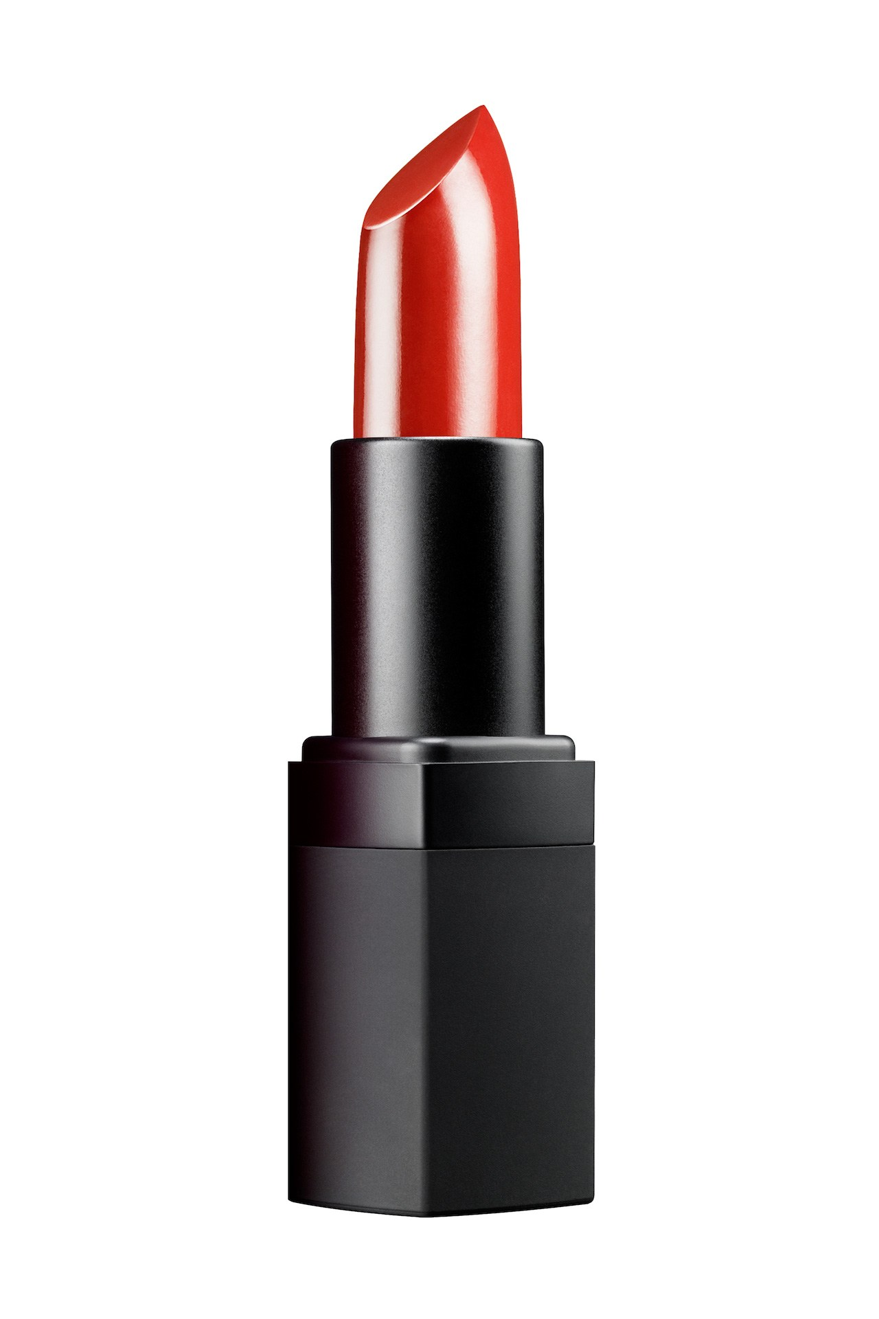

Beauty may come at a cost to your health. In 2007, at an independent lab,

the Campaign for Safe Cosmetics tested 33 popular brands of lipstick for

lead content. Results showed 61% of the products tested contained lead

with levels ranging up to 0.65 ppm (parts per million). Some of the lead-

contaminated brands included L’Oreal, Cover Girl and a $24 tube of

Dior Addict.

In response to pressure from consumers and a letter from three U.S. Senators, the FDA conducted a follow-up study (2009) using products from the 2007 Campaign study that were still on the market. Of the 20 samples tested, the lead levels ranged from 0.09 to 3.06 ppm (average level 1.07 ppm). These levels were **four times higher** than the levels found in the Campaign study. In the FDA study, the highest lead levels were found in lipsticks made by three manufacturers: Procter & Gamble (Cover Girl brand), L’Oreal (L’Oreal, Body Shop and Maybelline brands) and Revlon. Despite these findings, the FDA concluded that the lead levels were not a health issue.

In 2011, the FDA conducted an expanded survey testing 400 lipsticks available on the U.S. market. Results from the study detected lead content ranging from 0.026 ppm to 7.19 ppm. The average lead concentration was 1.11 ppm. Five of the 10 most lead-contaminated brands were manufactured by L’Oreal USA. The most contaminated brand in the study, Maybelline Color Sensation (L’Oreal USA) contained more than 275 times the amount of lead found in the least contaminated, and least expensive brand: Wet & Wild Mega Mixers Lip Balm. Price, therefore, does not seem to be a good indicator of manufacturing practices. The list of 400 lipsticks are available at <http://www.fda.gov/cosmetics/productsingredients/products/ucm137224.htm#expanalyses>

Because the average lead content in the expanded study was close to the 1.07 ppm obtained in the 2009 study, the FDA again deemed the lead levels not to be a safety concern. A statement on the FDA website claims, “The lead levels we found are within the limits recommended by other public health authorities for lead in cosmetics, including lipstick.”

The problem for consumers is that there is no safe dose or level set for lead exposure. According to medical and health experts, lead builds up in the body over time and lead-containing lipstick applied several times a day every day can add up to significant exposure levels.

**Lead and Health**

Lead is a heavy metal that, in high concentrations, can result in lead poisoning. It is a proven neurotoxin, capable of causing damage to nerves or nerve tissue. Toxic levels cause learning, language and behavioral problems, such as lowered IQ and increased aggression.

According to the Centers for Disease Control and Prevention (CDC), no safe blood lead level has been identified. Thereby, the CDC suggests avoiding all sources of lead exposure, including lead-containing cosmetics. On its website, the FDA’s Office of Cosmetics and Colors notes that it is considering setting an upper limit for lead in lipsticks, but at the time of this writing no such limit has been set.

**Lack of Regulation**

The Federal Food, Drug and Cosmetic Act (FD&C Act) prohibits the marketing of adulterated or misbranded cosmetics in interstate commerce. However, the FDA doesn’t regulate or limit the use of chemicals in personal-care products or require that all of the ingredients be listed on the label. Cosmetics products and ingredients are not subject to FDA premarket approval authority, with the exception of color additives.

Cosmetic firms are responsible for substantiating the safety of their products and ingredients before marketing. In general, except for color additives and those ingredients which are prohibited or restricted from use in cosmetics by regulation, a manufacturer may use any ingredient in the formulation of a cosmetic provided that

* the ingredient and the finished cosmetic are safe,
* the product is properly labeled, and
* the use of the ingredient does not otherwise cause the cosmetic to be adulterated or misbranded under the laws that FDA enforces.

Manufacturers do not list lead and many other toxins on packaging labels because they are considered to be impurities, not added intentionally but existing only as byproducts.

Watch an entertaining yet enlightening YouTube video at this link:

The Story of Cosmetics (2010) <https://youtu.be/pfq000AF1i8>

**Changes in the Making**

All is not lost, however. There are some positive changes under consideration. In California, the Department of Toxic Substances Control has signed a memorandum of understanding with the U.S. Environmental Protection Agency (EPA) to advance the state’s push for safer chemicals in everyday products: children’s toys, personal care products and other products.

In March 2012, the House Energy and Commerce Committee called the first official Congressional hearing on cosmetics safety in more than 30 years following recent debates over the levels of certain toxic chemicals present in cosmetic products. In recent years, some states have considered legislation that would affect the ingredients that can be used in cosmetic products. And, some groups have called for national standards for ingredients of cosmetic products that are reviewed by the FDA

The best case scenario would be a uniform standard for cosmetic ingredients that would serve both to further public health by ensuring decisions are made using sound science and ensure that the interstate flow of cosmetic products is not disrupted by differing State standards. President Obama’s 2013 proposed budget called for an additional $19 million in funding through user fees to enable the FDA to more effectively regulate cosmetics. This action resulted in the FDA issuing Good Manufacturing Practice recommendations for cosmetic products (color additives). In FDA guidances (2015), “The use of the word *should* … means that something is suggested or recommended, but not required.” Therefore, the cosmetic firms continue to conduct self-inspections to rate operations and product safety.

Want to test what you know about safe cosmetics according to the FDA?

Take the Cosmetics Quiz available at <http://www.accessdata.fda.gov/videos/cfsan/cosmeticsquiz/>

Author’s note: This article is an updated version from the original 2012 publication.

Resources:

FDA - U. S. Food and Drug Administration. (2015, June). Draft Guidance for Industry: Cosmetic Good Manufacturing Practices. Available at [www.fda.gov/cosmetics/guidanceregulation/guidancedocuments/ucm353046.htm](http://www.fda.gov/cosmetics/guidanceregulation/guidancedocuments/ucm353046.htm)

[www.fda.gov/cosmetics](http://www.fda.gov/cosmetics)

[www.safecosmetics.org](http://www.safecosmetics.org)

www.cdc.gov/nceh/lead/tips.htm

<http://www.dtsc.ca.gov/pollutionprevention/greenchemistryinitiative/index.cfm>

**The Truth about Dietary Supplements**

Cassandra Vanderpool, MS, RDN, LD

Extension Diabetes Coordinator

The National Health and Nutrition Examination Surveys (NHANES) and research conducted by the Council for Responsible Nutrition (CRN) have documented similar results regarding dietary supplement use: **approximately half of Americans regularly take dietary supplements**. Nearly 40% of dietary supplement sales are for supplements containing vitamins and minerals. Why are people taking dietary supplements? The most common responses are for “overall health and wellness” and “to fill nutrient gaps in the diet.” These sentiments align with marketing strategies used since World War II that portray vitamin and mineral supplements as a kind of health insurance. Another common assumption is that there is nothing to lose; a dietary supplement may not help me, but at least it won’t hurt me either.

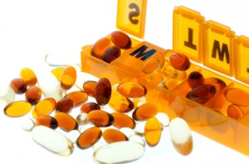

The National Institutes of Health, Office of Dietary Supplements posts fact sheets on its website that evaluate these beliefs. Overall, published research does not support that dietary supplements reduce the risk of any chronic disease. Most Americans meet recommended vitamin and mineral intakes from food alone. Multivitamin and mineral supplements increase the percent of individuals who meet the recommendations by a small amount. However, they also increase the percent of individuals who consume a potentially toxic level of certain nutrients, in particular vitamin A, iron, zinc, and niacin.

Dietary supplements come with some additional risks and costs. They may have a strong effect on the body and unexpected side effects. In particular, those who smoke, are pregnant, undergo surgery, or take medications or multiple dietary supplements should discuss the use of dietary supplements with their health care provider. Dietary supplements also carry a significant price tag, especially considering the poor evidence of any benefit. Americans spent an estimated $36.7 billion on dietary supplements last year.

Dietary supplements are not regulated by the Food and Drug Administration (FDA) to the same extent as prescription and over-the-counter drugs. The FDA developed “good manufacturing practices” for dietary supplements that manufacturers were required to adopt beginning in 2008-2010. These practices are intended to ensure that dietary supplements are consistent in their identity, purity, strength, and composition. Some manufacturers contract third-party organizations (i.e., U.S. Pharmacopeia, ConsumerLab.com, NSF International) to test the quality of their products, which then carry a seal of approval that they were properly manufactured, contain the ingredients listed on the label, and do not have harmful levels of contaminants. Still, these seals do not guarantee safety or effectiveness. Manufacturers are responsible for product safety and the truthfulness of their label claims, but they are not required to submit evidence to the FDA before putting dietary supplements on the market. The FDA may take action to remove a dietary supplement from the market if it finds evidence that the product is unsafe. This is very different from drugs, which cannot be marketed until sufficient evidence of safety has been provided to the FDA and it has approved the drug.

Research does support that supplementing specific nutrients in individuals and groups that experience a deficiency or increased need of those nutrients may provide benefits (e.g., folic acid and iron for pregnant women, vitamin B12 for people over age 50 and vegans, calcium and vitamin D for postmenopausal women). Individuals who are taking blood glucose-lowering medications, such as metformin, are at risk for folic acid and vitamin B12 deficiencies. Iron, calcium, and vitamin D are additional nutrients of concern in those with diabetes. Ideally, nutrient deficiencies are resolved by eating more of the foods that are high in those nutrients. When that is not possible or sufficient, it is appropriate to recommend a dietary supplement that provides the needed amount of nutrients, taking into account potential interactions with any other drugs or supplements consumed.

The bottom line is that dietary supplements are typically used unnecessarily. Individuals benefit more by eating a healthy diet as described in the 2010 Dietary Guidelines for Americans and MyPlate. Ironically, studies show that people with healthier diets and lifestyles are more likely to use dietary supplements. Those who are concerned that they may need to supplement their diet may want to consider consulting a Registered Dietitian or other health care provider before purchasing dietary supplements. An annual visit costs a fraction of what is typically spent on dietary supplements and results in individualized recommendations that may provide overall savings and greater health benefits.

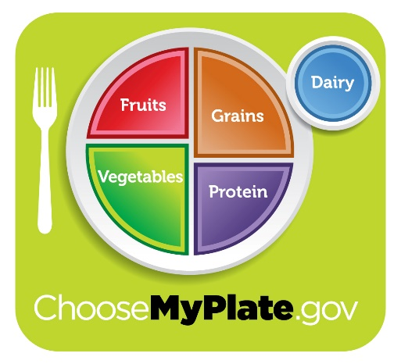

Resources:

Council for Responsible Nutrition. Dietary supplement use among U.S. adults more prevalent than previously thought, says new published review—users take supplements to improve overall health, fill nutrient gaps—. April 14, 2014. Available at <http://www.crnusa.org/CRNPR14-PublishedReviewConsumerSurveysJACN_04022014.html>, accessed July 13, 2015.

National Institutes of Health. Office of Dietary Supplements. Multivitamin/mineral supplements. July 8, 2015. Available at <https://ods.od.nih.gov/factsheets/MVMS-HealthProfessional/#en44>, accessed July 13, 2015.

National Institutes of Health. Office of Dietary Supplements. Dietary supplements: what you need to know. June 17, 2011. Available at <https://ods.od.nih.gov/HealthInformation/DS_WhatYouNeedToKnow.aspx>, accessed July 13, 2015.

Mobley-Bukstein W, Schleder M. Vitamin and mineral deficiencies in the person with diabetes. *On the Cutting Edge*, a bi-monthly publication of the Diabetes Care and Education (DCE) Dietetic Practice Group of the Academy of Nutrition and Dietetics. 2015;36:19-22.

**~~~~~~~~~~~~~~~~~~~~~~~~~~~~~~~~~~~~~~~~~~~~~~~~~~~~~~~~~~~~~~~~~~~~~~~~~~**

***~~~~~~~~~~~~* Invited Contributor *~~~~~~~~~~~***

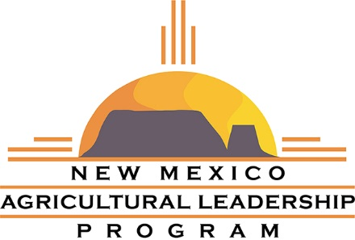

**Sharpening your Crayons**

Claudia Trueblood, Coordinator

What is the first thing that comes to mind when someone asks you to lead something: an effort, a meeting, a group, whatever it may be? Do you think, or even say: “me?” almost with skepticism? I have come to realize that most of us doubt the skills we possess and many times worry about being appointed to lead. But why? Why is it that we lack the confidence to take on leadership roles or that when we finally accept, we are not as effective as we could be?

My answer is simple, my crayons are not sharp! Have you ever tried to write or draw with dull crayons? Nightmare, right? Well, leadership skills are our tools and if we do not sharpen them and keep them sharp, they will be as ineffective and frustrating as dull crayons. I invite you to hone your skills by participating in the New Mexico Agriculture Leadership (NMAL) program.

The NMAL Program was founded in 2001 with the purpose of identifying and supporting effective leadership within the food, agriculture, and natural resource industries of New Mexico. The program aids participants, adults older than 25 years of age, in the development of leadership skills so that they become stronger and more effective leaders in their industries and communities. During the eighteen-month experience, participants meet nine times, including seven in-state seminars, a Washington D.C. learning experience, and a seminar at a national or international location.

This is your chance! NMAL is presently recruiting participants, both within and outside NMSU Extension, for the eleventh class. If you are interested in being part of the next class, download the application packet from <http://aces.nmsu.edu/nmal/application.html> and submit it via e-mail or regular mail by **August 20, 2015**. For more information please contact us at 575 646-6691 or [nmal@nmsu.edu](mailto:nmal@nmsu.edu).

Comments from the Alumni:

*“I enjoyed the variety NMAL offers. My favorite part was meeting people with diverse backgrounds and interests.”*

*“The program helped me become more aware of the world and of other people’s perspectives and issues.”*

*“Visiting with leaders from public and private organizations allowed me to see leadership issues and opportunities in different contexts.”*

*“Reflecting on my own leadership style gave me insight into what skills I needed to strengthen to become more effective at accomplishing my goals.”*