**Department of Extension Family and Consumer Sciences**

**Quarterly Newsletter**

**December 2012**

* **Health Hazards Associated with Laundry Detergent Pods**
* **Cooking Under Pressure**
* **Earned Income and Child Tax Credits**
* **Finding the Food Facts**
* **FSMA Implementation 2012**



**Health Hazards Associated with Laundry Detergent Pods**

Sonja Koukel, Ph.D.  
Community & Environmental Health Specialist

***Parents and caregivers should keep laundry detergent pods, as well as other household cleaning products, out of reach and out of sight of children -- CDC Report, October 2012***

Since 2010, laundry detergent pods have become a growing component of the U.S. laundry detergent market. Laundry detergent pods are single-load capsules that contain concentrated liquid detergent within a water-soluble membrane that dissolves when in contact with water. Parents and caregivers should be aware that young children might be drawn to laundry detergent pods because of their candy-like appearance. Exposure to laundry detergent from pods has been associated with severe adverse health effects.

During May – June 2012 the American Association of Poison Control Centers (AAPCC) reported 1,008 laundry detergent exposures of which 485 (48%) involved laundry detergent pods. Of the 485 pod-related reports, 482 (99%) were deemed unintentional, such as when a child gains access of a toxic substance and does not realize the danger. Among exposures, children aged 5 years and younger represented 454 (94%) of 481 pod exposures.

Exposure to laundry detergent in pods, especially among children aged 5 years and younger, is an emerging U.S public health hazard. The most frequently reported sign and symptom of exposure was vomiting (55%). Reported symptoms in the 454 reported incidents among children aged 5 years and younger included:

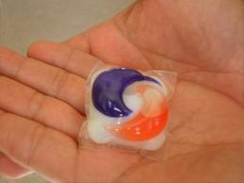

* Vomiting 251 (55%)
* Coughing/choking 70 (15%)
* Eye irritation/pain 51 (11%)
* Red eyes/conjunctivitis 38 (8%)
* Drowsiness/lethargy 34 (7%)
* Nausea 26 (6%)
* No effects 90 (20%)

Manufacturers have taken a number of actions to emphasize and educate consumers on the importance of keeping the detergent pods out of the reach of children and, further, helping to keep homes safe. Recently, the largest manufacturer of laundry detergent pods in the U.S. added a double-latch lid safety feature to the container in which its pods are sold.

In addition to the precautions stated on the labels, the industry is intensifying efforts to raise awareness of the simple steps that can help prevent accidental exposure to laundry detergent packets. These awareness-raising initiatives include messages in TV commercials, on-line advertising, print advertising, signage in retail stores, and information on product websites, along with “keep out of reach of children” icons on product packaging.

Re-emphasizing the safe and proper use of laundry detergent packets is vital, as these products are used every week by millions of consumers. The products provide the convenience of a premeasured quantity of detergent, making it easier for busy parents and caregivers to do home laundry. They also help consumers who are visually impaired or may experience limited physical dexterity.

The American Cleaning Institute has online consumer information on properly and safely using and storing the detergent packets: [www.cleaninginstitute.org/clean_living/laundry.aspx](http://www.cleaninginstitute.org/clean_living/laundry.aspx).

ACI also has tips on general laundry room safety available at [www.cleaninginstitute.org/clean_living/doing_laundry_the_safe_way.aspx](http://www.cleaninginstitute.org/clean_living/doing_laundry_the_safe_way.aspx).

Clinicians and caregivers are encouraged to report laundry detergent exposures and cases of associated illness to the local poison center 1-800-222-1222.

Source: *Health Hazards Associated with Laundry Detergent Pods – United States, May – June 2012*. Morbidity and Mortality Weekly Report *61*(41), 825-829. CDC.

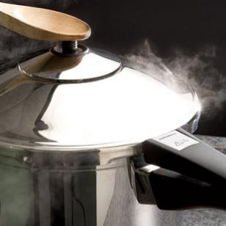

**Cooking Under Pressure**

Carol W. Turner, Ph.D., R.D., L.D.

Extension Food & Nutrition Specialist

“What’s for dinner?” The three most dreaded words in the English language, at least in my house. If I had planned my time better I could have prepared a wonderful meal for my family and had it simmering in the crock-pot. But like many of you, my mornings are packed with other responsibilities that often do not leave time for thinking about one more item on my To-Do List. I was recently introduced, or reintroduced to the pressure cooker.

Today's pressure cookers are literally foolproof. They all have locking lids and backup pressure release valves as well as collapsing gaskets, which serve as a third backup. You can't open it even by accident if there is any pressure inside.

Using a pressure cooker will help you:

* Reduce cooking time by 50% or more compared to conventional cooking techniques
* Decrease energy usage
* Keep your kitchen cool
* Make great tasting food with or without added fats
* Boost your nutrition by locking in flavor and color
* Make cooking meals change from boring to delicious

So, as long as you follow directions, you cannot hurt yourself with a pressure cooker. But you can get flavor-packed meals together in minutes that taste like they took all day. A good rule of thumb is that an ingredient will cook in one-quarter to one-third of the time it takes with another method.

The reason is simple. Putting the contents of the pot under pressure by trapping the steam raises the boiling point of water. Critics of pressure cooking are often people who like to monitor what’s going on in the pot. With this technique, it isn’t an option. It takes some getting used to, but the time savings is always worth the trade off.

Here are some tips to help get you started using your pressure cooker:

**How to know when the regulator has achieved a "slow, gentle rocking motion."** Water boils at 212° F and creates steam. In a pressure cooker, this steam is safely locked inside, allowing the temperature to increase higher than the boiling point and resulting in faster than normal cooking. On a basic weighted valve pressure cooker, when the pressure regulator begins to rock, 15 pounds pressure (250° F) is reached inside the pot. On ALL kinds of pressure cookers, it’s important to reduce the heat on the stovetop once pressure is reached. If the heat is not reduced, too much liquid will be released while the cooker is trying to maintain 15 pounds pressure. On a weighted valve pressure cooker, the regulator should be rocking gently and slowly. Just enough so you can hear that it is doing its job.

|  |
| --- |
|  |

**When pressure cooking at high altitudes, the cooking time should be increased.** Increase cooking times 5% for every 1000 feet above 2000 feet. Time increases as follows:

|  |  |  |  |
| --- | --- | --- | --- |
|  | 3000 ft.: 5% | 4000 ft.: 10% | 5000 ft.: 15% |
|  | 6000 ft.: 20% | 7000 ft.: 25% | 8000 ft.: 30% |

**Foods cook quickly in the pressure cooker, so precise timing is important** to avoid overcooking. The cooking time is measured from the point at which the correct level of pressure is reached. Use a timer! Use high heat to bring the pressure cooker up to pressure then ***reduce the heat to maintain a slow, steady level.*** When the specified cooking time is complete, reduce pressure in the cooker according to the directions in the recipe.

**Never overfill the pressure cooker.** Plugging or blocking of the vent pipe can occur if the cooker is overfilled. Many foods expand when cooked so if the cooker is overfilled, expansion of the food may prevent the pressure relief devices from functioning properly. Therefore, never fill the pressure cooker over 2/3 full. There are a few foods like rice, grains, dry beans and peas, and soups that expand so much when cooking that the cooker should not be more than 1/2 full. Most pressure cookers have markings on the inside of the pot for guidance. It is important to always follow manufacturer’s instructions when cooking these foods.

**A few foods to avoid.** Foods such as applesauce, cranberries, rhubarb, cereals, pastas, and dried soup mixes are not recommended for the pressure cooker. These foods expand so much as a result of foaming and frothing that they should never be cooked under pressure.

**Replace pressure cooker parts regularly.** A pressure cooker has parts that must be replaced regularly to ensure it will work properly for many years to come. On average, parts such as the sealing ring, overpressure plug, and rubber gasket from the air vent/cover lock should be replaced about every two years or sooner if the part is not functioning properly. Occasionally, a handle will break or a pressure regulator will be lost. If this happens, these and other pressure cooker parts can be purchased from the manufacturer or from a retailer that carries parts for your specific pressure cooker. Remember, pressure cooker parts are not interchangeable. Use only the parts made for your cooker. Refer to your manufacturer’s instruction manual.

**Store your pressure cooker in a dry place with the cover inverted on the body.** If the cover is locked in place during storage, unpleasant odors may form inside the unit and the sealing ring could become damaged.

Learning how to use a pressure cooker may take some time, but in the end it will save you more than time. Pressure cooked food can be delicious and nutritious. Tasty meals can be prepared in very little time while preserving nutrients and saving energy.



**Earned Income and Child Tax Credits**

Fahzy M. Abdul Rahman, Ph.D.

Family Resource Management Specialist

It may be a little too early to think about tax, but for many, tax time is the awaited season when they can get tax refunds – which may be used to fund end-of-the year holiday spending.



Two of the largest anti-poverty programs, Earned Income Tax Credit

(EITC) and Child Tax Credit (CTC) were designed to encourage

people to work and provide tax relief to lower income families.

As their names may suggest, Earned Income Tax Credit (EITC)

focuses on aiding the working poor, while Child Tax Credit (CTC)

provides some financial support to offset the cost of raising children.

Studies have found that these tax credits promote work, reduce

poverty, help families meet basic needs, improve children’s academic

performance, and boost future earnings later in life for EITC child recipients. Tax credit money from federal sources not only improves a household’s economic condition directly, but also boosts local economy. A study done for San Antonio TX in 2003 showed that each EITC dollar received generated a further $1.58 to local economy and each additional $37,000 results in one additional permanent job (Texas Perspectives, Inc., 2003).

Over 26.8 million EITC recipients took in almost $59.5 billion for 2010 tax year return (IRS, 2012b). Unfortunately, many eligible households are not claiming these credits. Center on Budget and Policy Priorities (CBPP) estimated that 20 to 25% of EIC eligible workers are not claiming EITC, which amounts to $10 billion of unclaimed EITC. Among the benefits of EITC are that it translates to as much as 45% pay increase, and both EITC and CTC lift more than 9 million above poverty in 2010, including 4.9 million children (CBPP, 2012).

For New Mexico, about 30,000 eligible families failed to claim EITC, which amount to between $74 and $136 in lost payment (Bowman, 2007). IRS (2012c) estimated 8,000 who had not filed 2008 tax return are eligible for EITC worth $7.4 million.

**How much are these tax credit worth?**

An overview of EITC and CTC is laid out in Table 1.

|  |  |
| --- | --- |
| **EITC** | **CTC** |
| * If you lived with a qualifying child for more than half the year, and you earned less than $36,920 ($42,130 if married), you can claim up to $3,169 in CTC benefits. * If you lived with two children and earned less than $41,952 * ($47,162 if married), you can claim up to $5,236. * If you lived with three or more children and earned less than $45,060 ($50,270 if married), you can claim EITC up to $5,891. * Workers not raising a family may be eligible for up to $475 if they earned less than $13,980 ($19,190 if married) and are between the ages of 25 and 64. | * If you lived with a qualifying child for more than half the year, you can claim up to $3,169 in CTC benefits. * A family that earns less than $3,000 is ineligible for the credit, and a family with two children that earns between $3,000 and $16,333 receives only a partial credit. * The value of the CTC increases with a household’s earnings before reaching the $1,000-per-child limit. |

Table 1. EITC and CTC Overview (IRS, 2011; IRS 2012a)

Based on information in Table 1, it is evident that the amount of tax credits differs by income level, tax filing marital status, and number of qualifying children – which are the main tax credit determinant with few other affecting factors not shown here. The EITC amount is shown in Figure 1.

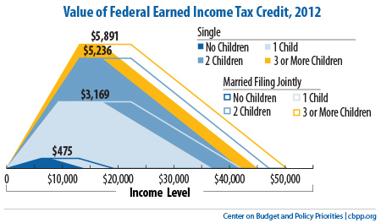

Figure 1. EITC Amount by Marital Status and Income Level. Source: CBPP (2012)

New Mexico is one of the 24 *states* (D.C. included) that also provide state EITC. Known as New Mexico Working Families Tax Credit, NM EITC amounts to a maximum of 10% of federal EITC. Its amounts, by number of qualifying children, are shown in Table 1.

|  |  |  |  |  |  |  |  |  |  |  |  |  |  |  |  |
| --- | --- | --- | --- | --- | --- | --- | --- | --- | --- | --- | --- | --- | --- | --- | --- |
| |  |  |  | | --- | --- | --- | | Number of qualifying children | Maximum federal EIC | Maximum NM Working Families Tax Credit | | none | $ 475 | $47.50 | | one | $3,169 | $316.90 | | two | $5,236 | $523.60 | | three or more | $5,891 | $589.10 | |

Table 1. New Mexico Working Families Tax Credit (Community Resources Information, Inc., 2012)

**Outreach Message**

Outreach message on EITC and CTC are three-fold:

1. **Outreach**: The largest financial returns likely come from promoting tax credits, with EITC average of 2,240 (2012 tax year).
2. **Free tax preparation**: Next, we need to encourage people to minimize tax filing costs. Paid tax filing averages about $100 per filing, which include per form fees and direct deposit filing. There are many free tax filing services across the national and state to low- and middle-income families. In New Mexico, [TAX HELP New Mexico](http://www.cnm.edu/taxhelp/) (1-888-212-4TAX, 505-244-4TAX) and IRS-organized [VITA Program](http://www.irs.gov/individuals/article/0,,id=107626,00.html) (1-800-829-1040) provide tax filing assistance filing. Their services may include services in Spanish and Navajo and advice to better manage the expected tax returns. If possible, encourage people to file their tax themselves so that they have a better idea about their income flow and its related tax issues (e.g. tax brackets, deductions).
3. **How to better manage your tax returns money**: Having high income does not guarantee financial security. We have been hearing stories about athletes and celebrities who make millions of dollars annually ending up in bankruptcy. Better ways to manage tax returns include paying debt, saving in a matching program (e.g. Individual Development Account), and settling bills.

**Reference**

Bowman, Leslie (2009). New Mexicans lose out on millions in unclaimed tax credits. *The New Mexico Independent* 1/30/2009. Retrieved March 16, 2009 from http://newmexicoindependent.com/16929/take-charge-with-tax-credits

Center on Budget and Policy Priorities (2012). Policy Basics: The Earned Income Tax Credit. Retrieved December 1, 2012 from http://www.cbpp.org/cms/index.cfm?fa=view&id=2505

Community Resources Information, Inc. (2012). Earned Income Credit (EITC): An Overview (2012). Retrieved November 21, 2012 from http://www.newmexicoresources.org/pages.cfm?contentID=34&pageID=12&Subpages=yes

IRS (2011). Ten Facts about the Child Tax Credit: IRS Tax Tip 2011-29, February 10, 2011. Retrieved November 23, 2012 from http://www.irs.gov/uac/Ten-Facts-about-the-Child-Tax-Credit

IRS (2012a). EITC Statistics: Nationwide in 2011. Retrieved November 22, 2012 from http://www.eitc.irs.gov/central/eitcstats/

IRS (2012b). EITC, Earned Income Tax Credit, Questions and Answers. Retrieved December 1, 2012 from http://www.irs.gov/Individuals/EITC,-Earned-Income-Tax-Credit,-Questions-and-Answers

IRS (2012c). Individuals Who Did Not File a 2008 Return with a Potential Refund. Retrieved November 15, 2012 from http://www.irs.gov/uac/IRS-Has-$1-Billion-for-People-Who-Have-Not-Filed-a-2008-Income-Tax-Return

Texas Perspectives, Inc. (2003), Increased Participation in the EITC in San Antonio. Retrieved November 09, 2012 from <http://www.aecf.org/~/media/Pubs/Initiatives/Making%20Connections/I/IncreasedParticipationEITCSanAntonio2/SAEITCdoc.pdf>

**Finding the Food Facts**

Cassandra Vanderpool, M.S., R.D., L.D.

Extension Diabetes Coordinator

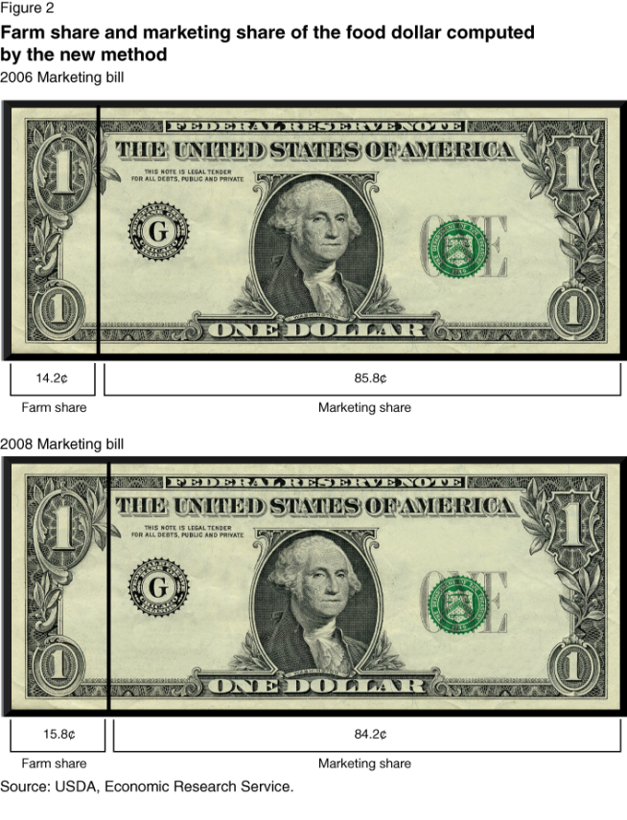

An alarming amount of money goes into food marketing. Take a look at this photo from the USDA 2008 marketing bill series, which estimates that less than 20% of the money we spend on food goes to pay for the food itself!

Food manufacturers include various claims on their packaging and in their advertising to induce consumers to buy their product. You cannot escape words like “natural,” “smart choice,” “sensible,” “sugar free,” and seemingly endless others while shopping the aisles of the grocery store. How do you know if the product really provides what you think it does?

The Nutrition Facts label has been required by law for over 18 years now! Use it with the Ingredients list to become a savvy shopper. Here are some quick tips to help you find out what you are really getting from your food:

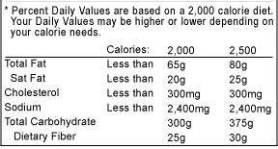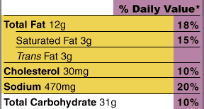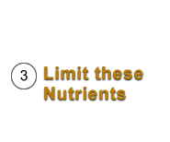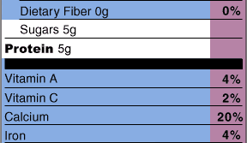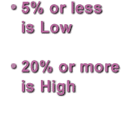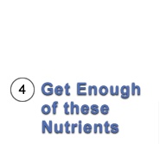

1. Start with the **Serving Size**

This shows the amount for one serving and the number of servings per container, in this case a box of macaroni and cheese. It tells you that eating what the box makes gives you 500 calories, not just 250, because there are two servings in the box. Double everything else on the label also.

1. Watch the **Calories** and **Fat**

Cutting back on calories can help you manage your weight. Saturated Fat and *Trans* Fat are required on all labels. Limit them because they raise LDL (bad) cholesterol. Unsaturated fats are healthy.

1. Limit **Sodium**

Eating less sodium may reduce your risk of high blood pressure.

1. **Carbohydrate** clues

Below Total Carbohydrate, you will find Dietary Fiber and Sugars. The rest of the carbohydrates are usually from starches. Fiber is good for your digestive system and helps you feel full.

Sugars are simple carbohydrates, which may occur naturally in the food or which may be added to the food. You have to search the Ingredients list to find out if they are added. Limit products that have added sugar near the top of the Ingredients list or that have several added sugars listed in the Ingredients. How do you spot them? Here are some of the more common sources:

* Sugars (e.g., brown sugar, raw sugar, etc.)
* Words that end in “ose” (e.g., sucrose, fructose, etc.)
* Syrups (e.g., corn syrup, malt syrup, etc.)
* Nectars (e.g., agave nectar, apricot nectar, etc.)
* Fruit juice concentrates
* “Cane” sources (e.g., cane crystals, cane juice, etc.)
* Molasses

1. Using **% Daily Value**

Percent Daily Values (DV) are based on a 2,000 calorie diet. If that is not the appropriate amount for you, you may need more or less than 100% DV from the foods you eat throughout the day. Whether or not you need 2,000 calories daily, you can use % DV to help you choose foods. A food is considered low in a nutrient if it has 5% DV or less. Aim low in saturated fat, cholesterol, and sodium. 20% or more is high. Aim high in vitamins, minerals, and fiber.

Adapted from [www.eatright.org](http://www.eatright.org), [www.fda.gov](http://www.fda.gov), and [www.usda.gov](http://www.usda.gov) resources.

**FSMA Implementation 2012**

Nancy Flores, Ph.D.

Extension Food Technology Specialist

The new Food Safety Modernization Act (FSMA) amended section 415 of the Federal Food, Drug, and Cosmetics Act (FD&C Act) [21 U.S.C. § 350d], which requires domestic and foreign facilities that manufacture, process, pack or hold food for human or animal consumption in the U.S. to register with FDA. Facility registration allows FDA to maintain focus on improving the agency's ability to respond to a food-related emergency quickly and efficiently. Registration opened on October 22, 2012. The FSMA registration is free of charge but some consultants offering assistance will charge for their service. Operations that are affected by the law are any that manufacture, process, pack, transport, distribute, receive, hold, or import articles of food.

Examples of agriculture commodity facilities that must register for a FSMA facility code are fresh cut and packaged raw fruit; fresh cut and packaged raw produce including packaged salad greens; roasted and packaged raw nuts and seeds. Storage facilities must also register if holding products such as whole and milled grains (including elevators); oilseeds such as cottonseed and sunflower, alfalfa products or Lespedeza products. Additionally facilities handling or producing ingredients for animal feed and pet food must also register. Any food processors that registered for the 2002 Bioterrorism Act must also register for FSMA facility code. The ***Guidance for Industry: Necessity of the Use of Food Product Categories in Food Facility Registrations and Updates to Food Product Categories*** (found at: <http://www.fda.gov/Food/GuidanceComplianceRegulatoryInformation/GuidanceDocuments/ucm324778.htm>) identifies the following as food product categories that are mandatory fields in the food facility registration form:

Acidified Food (see 21 CFR 114.3(b))

Baby (Infant and Junior) Food Products Including Infant Formula

Cheese and Cheese Product Categories: Soft, Ripened Cheese; Semi-Soft Cheese; Hard Cheese; Other Cheeses and Cheese Products

Dietary Supplement Categories: Proteins, Amino Acids, Fats and Lipid Substances; Animal By-Products and Extracts; Herbals and Botanicals

Fishery/Seafood Product Categories: Fin Fish, Whole or Filet; Shellfish; Ready to Eat

(RTE) Fishery Products; Processed and Other Fishery Products

Fruit and Fruit Products: Fresh Cut Produce; Raw Agricultural Commodities; Other Fruit and Fruit Products

Fruit or Vegetable Juice, Pulp or Concentrate Products

Low Acid Canned Food (LACF) Products (see 21 CFR 113.3(n))

Nuts and Edible Seed Product Categories: Nut and Nut Products; Edible Seed and Edible Seed Products

Shell Egg and Egg Product Categories: Chicken Egg and Egg Products; Other Egg and Egg Products

Vegetable and Vegetable Product Categories: Fresh Cut Products; Raw Agricultural Commodities; Other Vegetable and Vegetable Products

If none of the human food categories listed in the registration form applies, print the applicable food category or categories.

Additional Food Product Categories for Foods for Animal Consumption:

Grain or Grain Products (i.e., barley, grain sorghums, maize, oat, rice, rye, wheat, other grains or grain products)

Oilseed or Oilseed Products (i.e., cottonseed, soybeans, other oilseeds or oilseed products)

Alfalfa Products or Lespedeza Products*;Amino Acids or Related Products

Animal-Derived Products

Brewer Products

Chemical Preservatives

Citrus Products

Distillery Products

Enzymes

Fats or Oils

Fermentation Products

Marine Products

Milk Products

Minerals or Mineral Products

Miscellaneous or Special Purpose Products

Molasses or Molasses Products

Non-protein Nitrogen Products

Peanut Products

Recycled Animal Waste Products

Screenings

Vitamins or Vitamin Products and Yeast Products

Mixed Feed (e.g., poultry, livestock, equine)

Pet Food

Pet Treats or Pet Chews

Pet Nutritional Supplements (e.g., vitamins, minerals)

If none of the above food categories apply, print the applicable food category or categories (that does not or do not appear above).

Small food processors are exempt from FSMA registration if they qualify under the following conditions:

* Sales Less than $500,000 (avg. 3 years)
* Sell directly to consumers restaurants/retailers in the same state or within 275 miles from facility

Qualified small operation are exempt from the FSMA regulations but not exempt from recall procedure or trace back and not exempt from risk analysis. Although some people are concerned if they need to register their food processing facility, there are other issues they need to be aware of to be in compliance with the food safety law. Other requirements of the FSMA law are:

* Follow new science-based standards for producing and harvesting raw agricultural commodities
* Recordkeeping requirements for high-risk foods
* Follow new safety and security guidelines for the importation of food, among other regulations
* Develop written food safety plans that address risk associated with commodity
* All records and written plans related to food production or processing would be made available to FDA.
* Traceability or trace back records kept with the source of incoming product and the initial destination of outgoing product.
* Traceability also requires facility name and address on all packages or placard on bulk displays

Registration involves completing a form with contact information and under sections 10a check off from a list the activities done at the facility. Most agriculture commodities produced in New Mexico will fall under the food facility commodities and activities presented. Step by step instructions for completing forms can be found at this link: <http://www.fda.gov/Food/GuidanceComplianceRegulatoryInformation/RegistrationofFoodFacilities/OnlineRegistration/ucm073706.htm>

The links to registration for electronic online: www.access.fda.gov; or the paper form can be downloaded at: <http://www.fda.gov/downloads/AboutFDA/ReportsManualsForms/Forms/UCM071977.pdf>

Food facilities that have registered and do not have their FURLS information or PIN should not re-register. Instead, a food facility can contact U.S. FDA for help at 1-800-216-7331 (301-575-0156 outside the United States), or by e-mail at [furls@fda.hhs.gov](mailto:furls@fda.hhs.gov).

For more information contact your local county extension office or the New Mexico Department of Agriculture.