**Department of Extension Family and Consumer Sciences**

**Quarterly Newsletter**

**JANUARY 2015**

**In this issue:**

* **Fight the Flu**
* **Top 10 Signs the U.S. is Building a Culture of Health**
* **Fermentation – Everything old is new again**
* **Simple Steps to Lower Sodium**



**Fight the Flu**Sonja Koukel, Ph.D.  
Community & Environmental Health Specialist

The flu season is upon us. Health experts predict this year will see an increase in influenza activity over previous years. Currently (week ending December 20, 2014), [New Mexico outpatient visits for flu-like illness](http://nmhealth.org/publication/view/data/1223/) were reported at 3.9%, which is above the national baseline (2%) and an increase from last week (2.3%). So far, a total of 21 influenza-associated deaths have been reported during the 2014-2015 season (approximately, September – December, 2014) – with no deaths reported in New Mexico.

Many of us are familiar with the flu – having personally suffered through the illness. However, a review of the basic information and how to prevent contracting the flu is worth repeating.

Flu basics  
Flu is a contagious respiratory illness caused by two main types of influenza virus: Types A and B. Getting the flu feels awful. Sometimes it can be dangerous and lead to sever illness and complications, including death. Symptoms include:

* Fever (usually high, but not everyone with flu will have a fever)
* Headache
* Extreme tiredness
* Dry cough
* Sore throat
* Runny or stuffy nose
* Muscle aches
* Stomach symptoms (such as nausea, vomiting, and diarrhea can happen, but are more common in children than adults)

How the flu differs from the common cold  
The flu and the common cold are both respiratory illnesses but they are caused by different viruses. The symptoms are very similar, but generally, the flu is worse than the common cold, and symptoms with the flu are more intense. People with colds are more likely to have a runny or stuffy nose. Colds generally do not result in serious health problems, such as pneumonia, bacterial infections, or hospitalizations.

Because people with colds and flu have many of the same symptoms, it can be difficult (or even impossible) to tell the difference between a cold and the flu based on symptoms alone. Special tests that usually must be done within the first few days of illness can be carried out by medical professionals, when needed, to tell if a person has the flu.

Flu complications  
Most people who get influenza will recover in a few days to less than two weeks, but some people will develop complications (such as pneumonia) as a result of the flu, some of which can be life-threatening and result in death.

Pneumonia, bronchitis, sinus and ear infections are examples of complications from flu. The flu can make chronic health problems worse. For example, people with asthma may experience more frequent and worse asthma attacks while they have the flu, and people with chronic congestive heart failure may experience worsening of this condition that is triggered by the flu.

Flu is contagious  
The flu is spread person to person. People with flu can spread it to others up to about 6 feet away. Most experts think that flu viruses are spread mainly by droplets made when people with flu cough, sneeze, or talk. These droplets can land in the mouths or noses of people who are nearby or possibly be inhaled into the lungs. Less often, a person might also get flu by touching a surface or object that has flu virus on it and then touching their own mouth or nose.

Most healthy adults may be able to infect other people beginning one day before symptoms develop and up to five to seven days after becoming sick. Children may pass along the virus for longer than seven days. Prior to the holiday break, [some states](http://www.newschannel9.com/news/top-stories/stories/local-schools-closed-friday-due-flu-14286.shtml) chose to close schools due to the flu, high absenteeism and fears that the numbers could increase if the schools remained open.

Symptoms start one to four days after the virus enters the body. That means that you may be able to pass on the flu to someone else before you know you are sick, as well as while you are sick. Some people can be infected with the flu virus but have no symptoms. During this time, those persons may still spread the virus to others.

Prevention: Vaccinations   
The Centers for Disease Control and Prevention continues to encourage influenza vaccination and prompt treatment with flu antiviral drugs for everyone six months of age and older every year. It is especially important for people at high risk of serious flu complications, including people 65 and older, children younger than 5 years (and especially those younger than 2 years), pregnant women and any person with [certain health conditions](http://www.cdc.gov/flu/about/disease/high_risk.htm). Flu vaccine is not approved for children younger than 6 months of age.

Prevention: Good Habits

1. **Avoid close contact** with people who are sick. When you are sick, keep your distance from others to protect them from getting sick too.
2. If possible, **stay home** from work, school, and errands when you are sick. You will help prevent others from catching your illness.
3. **Cover your mouth and nose** with a tissue when coughing or sneezing. It may prevent those around you from getting sick.
4. **Wash your hands often** to help protect yourself from germs. If soap and water are not available, use an alcohol-based hand rub if your hands are not visibly soiled.
5. **Don’t touch your eyes, nose or mouth.** Germs are often spread when a person touches something that is contaminated with germs and then touches his or her eyes, nose, or mouth.
6. **Practice other good health habits.**
7. Clean and disinfect frequently touched surfaces at home, work or school, especially when someone is ill. Surfaces include phones (cell and landlines), computer keyboards / mouse, door handles, chair arms, and others.
8. Get plenty of sleep, stay physically active, manage your stress, drink plenty of fluids, and eat nutritious food.

For quick and easy reference to the nearest flu shot clinic available to you, please call Nurse Advice New Mexico at **1-877-725-2552**.

Resources:  
Centers for Disease Control and Prevention (January 2015). <http://www.cdc.gov/flu/news/flu-activity-expands.htm>  
NM Department of Health (January 2015). <http://cpasw.nmsu.edu/>

**Top 10 Signs the U.S. is Building a Culture of Health**Sonja Koukel, Ph.D.  
Community & Environmental Health Specialist

Last January the Robert Wood Johnson Foundation (RWJF) alerted the world to its new strategy: To build a Culture of Health for all, one that would allow every one of us to make healthy choices wherever we live, work, and play. A big reach, we know, but we are nothing if not optimistic. So, 12 months on, we asked ourselves—How are we doing? Answer: Pretty good, as it turns out. Here are the top 10 signs that America is moving towards a Culture of Health (in no particular order).

**10. The evidence is in—kids are beginning to slim down.**

[Research published in February](http://www.rwjf.org/en/research-publications/find-rwjf-research/2013/09/signs-of-progress.html) shows continued signs of progress toward reversing the childhood obesity epidemic: Obesity prevalence among 2 to 5 year olds dropped by approximately 40 percent in eight years, a remarkable turnaround. There is still much work to do in this area, but at least our youngest kids can look forward to a healthier future.

**9. Kids are also eating healthier lunches—and *liking* them.**

In July a [study funded by RWJF](http://www.rwjf.org/en/about-rwjf/newsroom/newsroom-content/2014/07/school-leaders-report-widespread-student-acceptance-of-healthier.html) revealed that 70 percent of elementary school leaders

nationwide said their students generally like the healthier school lunches that rolled out in fall 2012. Middle school students (70 percent) and high school students (63 percent) also reported liking the meals.

**8. Mobile Health (**[**mHealth**](http://en.wikipedia.org/wiki/MHealth)) **has arrived! Silicon Valley is putting its innovators to work developing mobile apps that will help us get healthier.**  
 When Apple introduced its latest iPhone in June 2014, much of the excitement was around [Healthkit](http://www.theverge.com/2014/6/2/5772074/apple-healthkit-ios-8-announcement), a new mobile app that will help consumers track their health. Google, Samsung, and Microsoft also rolled out [health tracking devices](http://www.mhealthnews.com/news/top-5-healthkit-apps-so-far) and/or platforms this year. These metrics are intended to motivate consumers to take more responsibility for their own healthcare and wellness – results remain to be seen.



**7. The new trend in offices—sitting is bad, walking is**

**good.**

A [Washington Post illustration](http://apps.washingtonpost.com/g/page/national/the-health-hazards-of-sitting/750/?hpid=z8&omnicid=18) showing the dangers to

our health of sitting all day became wildly popular this

year, and more people started taking their meetings on

foot. NMSU employees are finding the treadmill desk

increases activity and pumps fresh blood and oxygen

through the brain reducing “foggy brain.”

**6. Cycling takes off.**

2014 could be called the year of the bicycle. At least

***“Brooke Boren, NMSU, working at her treadmill desk”***

36 urban areas now have bike sharing programs, up from

just six four years ago. Even small cities and towns are

embracing pedal power.

[New Mexico has a tremendous biking culture](http://www.bikenm.org/)with

strong participation in all forms of cycling: road, mountain,

cyclocross, BMX, tri-, cruiser, commuter, competitive and

recreational.

**5. Workplace wellness programs are spreading—even cigarette makers are getting with the program.**  
 Over the next three to five years, 48 percent of employers intend to put in place [workplace wellness programs](https://www.linkedin.com/pulse/20140117184103-43742182-workplace-wellness-not-just-about-the-dollars?_mSplash=1) that improve productivity and reduce absences.  Among the more surprising ones—in October, [Reynolds American, the second-largest U.S. cigarette company, announced that smoking is banned](http://www.usnews.com/news/articles/2014/10/23/cigarette-company-announces-workplace-smoking-ban) inside its facilities. “We believe this is the right thing to do and the right time to do it,” a Reynolds American spokesman told *U.S. News & World Report*.

**4. CVS Health kicks the cigarette habit and demonstrates that good health is also good business.**  
 In September [CVS stopped selling all tobacco products](http://www.rwjf.org/en/blogs/culture-of-health/2014/09/no_more_tobacco_behi.html) in its 7,700 stores nationwide, forgoing $2 billion in annual sales. It is the only national drugstore chain so far to take this important step. “Tobacco just doesn’t fit in,” said CVS’s chief medical officer. CVS’s stock price rose on the news.

**3. California voters pass the nation’s first city tax on soda.**  
 In November voters in [Berkeley, Calif.](http://www.usatoday.com/story/news/nation-now/2014/11/05/berkeley-passes-soda-tax/18521923/), passed the nation’s very first tax on sugary beverages. Proponents of the Berkeley tax say the fee will help curb consumption of sodas, energy drinks and sweetened iced teas, beverages they say are contributing to the nation's obesity epidemic.

**2. College campuses are becoming hotbeds of health.**  
 There are now 1,477 tobacco-free college campuses (Oct. 2014), up from 446 just four years ago. Of these, 975 are 100% tobacco-free, and 291 prohibit the use of e-cigarettes anywhere on campus. In New Mexico, UNM became a tobacco-free campus in 2009. NMSU and most other campuses have a smoking policy. Currently, NMSU is considering a ban on all tobacco products.

The infamous Freshman 15 has shrunk to a [Freshman 3 to 6](http://www.theatlantic.com/health/archive/2014/09/the-freshman-15-is-a-myth/379587/) at many campuses. (It is worth noting that this weight gain trend is scientifically unsubstantiated.)

The Princeton Review now rates college health facilities. A sign perhaps, that the 20- something generation will create their own Culture of Health.

And finally, the Number One sign that we are making progress:

**1. Thanks to the Affordable Care Act, some 13 million formerly uninsured people are now covered by health insurance.**  
 [The rate of uninsured people in the U.S.](http://hrms.urban.org/briefs/Health-Insurance-Coverage-under-the-ACA-as-of-September-2014.html) dropped by more than 30 percent from September 2013 to September 2014. As of December 2014, more than [17 thousand New Mexico Residents](http://www.healthinsurance.org/new_mexico-state-health-insurance-exchange/) had completed their enrollments through the Exchange. Health insurance carriers in the NM exchange are predicting up to 55,000 enrollees in 2015. There were 34,000 enrolled in 2014.

Top of Form

Bottom of Form

Resource:  
Arnst, C. (December 17, 2014). Culture of Health Blog. Available at http://www.rwjf.org/en/blogs/culture-of-health/2014/12/top_10_signs_we_are.html?rid=41wI5c047E2_2Ds4ua3XBZLWJKleae3J&et_cid=140116

**Fermentation – Everything old is new again**

Carol W. Turner, Ph.D.

Food & Nutrition Specialist

It seems as if everyone is jumping on the fermentation bandwagon, from chefs to health experts. But this is far from being just another foodie trend; this process has been around for centuries. The only difference today is that food is being fermented not only to last longer and taste better but because more and more research shows it has the potential to make us healthier.

Fermentation has long been part of human history. In fact, food scientists say that it played a vital role in human survival in the days before stoves and refrigerators simply because it allowed people to preserve food in a nutritional and safe way. Some of the more familiar fermented foods include sauerkraut (fermented cabbage), yogurt (fermented milk) and soy sauce made from fermented soybeans. Some of the new and popular foods include kimchi, made from radishes, cucumbers or other vegetables; kefir which is a drink made from milk; and kombucha which is a fermented tea.

***What is fermentation?***

Sandor Katz in *The Art of Fermentation* (2012) describes fermented food as “the flavorful space between fresh and rotten.” Technically speaking it is the conversion of carbohydrates to alcohols and carbon dioxide or organic acids using yeasts, bacteria, or a combination in conditions that lack oxygen. In simple terms it can be defined as a chemical alteration that transforms substances into simpler, more easily digestible compounds that provide digestive enzymes, friendly bacteria, and other nutrients.

Fermenting food not only increases the richness and flavor of the food or beverage, but also increases the beneficial flora and enzymes considerably, providing assistance to digestive and colon health.

***Why are they good for you?***

The human body carries more than 100 trillion bacteria – about 5 pounds. In fact, there are more bacteria in your body than cells. Scientists tell us that each has a unique bacterium “fingerprint” created by genes, environmental factors, medication, and our daily menu. More scientists and health professionals are beginning to believe that this landscape of microflora in the human body may be the key to a person’s health. Eating fermented foods is a simple way to inoculate your body with good bacteria.

It is the live microbes (or “probiotics”) in fermented foods that have brought these foods into the spotlight. Fermentation can increase the nutritional profile of foods by adding more easily digestible vitamins and minerals. In a healthy human gut, bacteria are mostly beneficial and it helps in digestion, extracting nutrients from food, and defending us from harmful bacteria.

The process of fermenting food, also called lacto-fermentation, is carried out by several strains of “good bacteria” and beneficial yeasts. By consuming foods rich in these organisms the benefits are transferred to your gut. Studies have also shown that eating fermented food increases vitamin intake as some microorganisms produce vitamins during the process, as well as increase the available nutrients our bodies can use.

Current areas of research include: inflammatory bowel disease, prevention of infant allergies, the link between gut bacteria and obesity, and metabolic disorders such as diabetes.

***Are they safe?***

Fred Breidt, a microbiologist from the USDA, said that when it comes to vegetables, fermentation is probably safer than eating them raw or canning them. This is because bacteria in fermentation are great at killing other unsafe bacteria during the fermentation process. However, for many popular products there are not yet any science-based guidelines for safe production. Tested recipes for consumers support the home-manufacture of sauerkraut, genuine dill pickles, and yogurt. The home-manufacture of other products is not recommended since safe guidelines have not been established. For this reason New Mexico State University Extension recommends trying recipes outlined by reliable sources such as the USDA and the National Center for Home Food Preservation.

***Get your daily fermented foods***

The best reason to eat fermented foods is flavor. The process of fermenting adds layers upon layers of complexity to foods. Think about the difference in flavor between milk and cheese, or cabbage and sauerkraut, or grape juice and wine. Try these easy options:

**Yogurt:** Milk that has been cultured with two very specific strains of bacteria: *streptococcus thermophiles* and *lactobacillus bulgaricus*. When shopping, look for plain yogurt containing nothing but cultures and milk.

**Kimchi:** Is made like sauerkraut but may contain different types of vegetables and seasonings, sugar, and often some type of dried or fermented fish product.



**Pickles:** Traditionally, dill pickles were made through fermentation. Now they are most often made with vinegar. The traditional types are making resurgence, and can be found in specialty stores carrying local products.

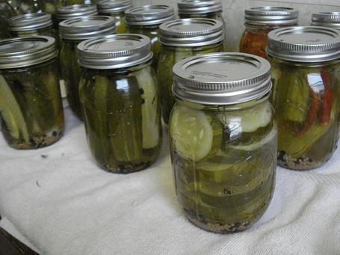

**Sourdough bread:** Fermented with the help of wild yeasts that are unique to a region, climate, or even a kitchen. Mixing wild yeast culture into flour and water to make bread will create bubbles that cause the bread to rise, and give the bread a characteristic sour taste.



**Salami:** As well as other cured meats made the traditional way are actually fermented The meat is mixed with salt and spices, inoculated with a special culture, and then allowed to cure naturally, without additives.



**Miso:** This soup is well-known among fans of Japanese food, but many people are unaware it’s a fermented food. The most common type is made from a paste of soybeans mixed with tofu and green onions.



**Kefir:**This Eastern European drink is a fizzy, tangy milk product made with live kefir cultures and is similar to yogurt. It can also be a water-based drink.

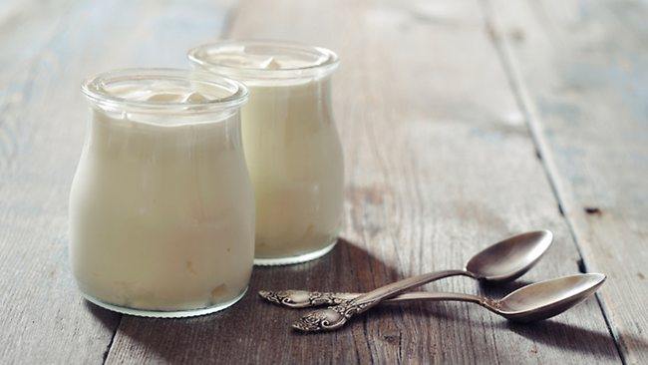

**Kombucha tea:** This is made with tea, sugar, bacteria and yeast, and fans say it has health benefits ranging from anti-ageing effects to gut flora health. There is no scientific research to support these claims, but there have been several cases of harm reported after drinking this tea. It may be prudent to avoid this tea until more definitive information is available.

**Simple Steps to Lower Sodium**

Cassandra Vanderpool, M.S., R.D.N., L.D.

February is American Heart Month. Heart disease is the leading cause of death for men and women in the United States. Every year, 1 in 4 deaths are caused by heart disease. The good news? Heart disease can often be prevented when people make healthy choices and manage their health conditions. This is especially important for adults with diabetes, who are 2 to 4 times more likely to have heart disease or a stroke than adults without diabetes.

Small changes can make a big difference in your heart health. For example, most people eat much more sodium (salt) than they need. This can lead to health problems like high blood pressure. You can lower your sodium intake by following some of these tips when you go shopping:

* Choose fresh instead of processed foods when you can.
* Use the Nutrition Facts label to check the amount of sodium. Look for foods with 5% Daily Value (DV) or less. A sodium content of 20% DV or more is high.
* Look for foods labeled “low sodium,” “reduced sodium,” or “no salt added.”

Take the list below with you the next time you go food shopping.

**Vegetables and Fruits**

Choose fresh or frozen vegetables and fruits when possible.

* Any fresh fruits, like apples, oranges, or bananas

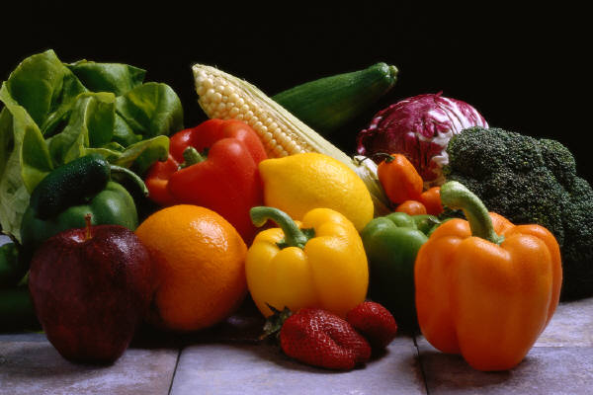

* Any fresh vegetables, like spinach, carrots, or broccoli
* Frozen vegetables without added sauce
* Canned vegetables that are low in sodium or have no salt added
* Low sodium vegetable juice
* Frozen or dried fruit (unsweetened)
* Canned fruit (packed in water or 100% juice)

**Breads, Cereals, and Grains**

Compare labels to find products with less sodium. When you cook rice or pasta, don’t add salt.

* Rice or pasta

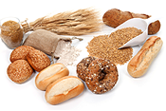

* Unsweetened oatmeal
* Unsalted popcorn

Tip: If your food comes with a seasoning packet, use only part of the packet. This will lower the amount of sodium in the food.

**Meats, Nuts, and Beans**

Choose fresh meats when possible. Some fresh meat has added sodium, so always check the label.

* Fish or shellfish

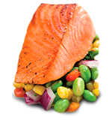

* Chicken or turkey breast without skin
* Lean cuts of beef or pork
* Unsalted nuts and seeds
  + - * + Peas and beans
        + Canned beans labeled “no salt added” or “low sodium”
        + Eggs

**Milk and Milk Products**

Choose fat-free or low-fat milk and yogurt. Be sure to check the label on cheese, which can be high in sodium. Milk and yogurt are also good sources of potassium, which can help lower blood pressure.

* Fat-free or low-fat (1%) milk

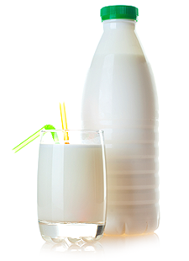

* Fat-free or low-fat yogurt
* Low- or reduced-sodium cheese (like Natural Swiss Cheese)
* Soy milk with added calcium

**Dressings, Oils, and Condiments**

When you cook, use ingredients that are low in sodium or have no sodium at all.

* Unsalted margarine and spreads (soft, tub, or liquid) with no *trans fats*

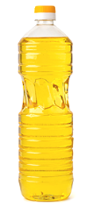

* Vegetable oils (canola, olive, peanut, or sesame)
* Sodium-free, light mayonnaise and salad dressing
* Vinegar

**Seasonings**

Try these seasonings instead of salt to flavor your food.

* Herbs, spices, or salt-free seasoning blends

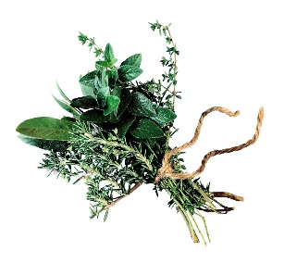

* Chopped vegetables, such as garlic, onions, and peppers
* Lemons and limes
* Ginger

Herbs are often associated with certain dishes and styles of cooking. As you prepare foods, try adding one or combining several of the recommended herbs.

|  |  |
| --- | --- |
| **Beef** | Bay, chives, cloves, cumin, garlic, hot pepper, marjoram, rosemary, savory |
| **Breads** | Caraway, marjoram, oregano, poppy seed, rosemary, thyme |
| **Cheeses** | Basil, caraway, chervil, chives, curry, dill seed, garlic chives, marjoram, oregano, parsley, sage, thyme |
| **Eggs** | Basil, dill weed, garlic, parsley |
| **Fish** | Bay, chervil, dill weed, fennel, garlic, parsley, sage, savory, tarragon, thyme |
| **Fruits** | Anise, cinnamon, coriander, cloves, ginger, lemon verbena, mint, rose, geranium |
| **Lamb** | Garlic, marjoram, oregano, rosemary, thyme |
| **Pork** | Black pepper, coriander, cumin, garlic, ginger, hot pepper, sage, savory, thyme |
| **Poultry** | Garlic, marjoram, oregano, rosemary, savory, sage |
| **Salads** | Basil, borage, chives, garlic chives, parsley, sorrel, tarragon |
| **Soups** | Bay, chervil, marjoram, parsley, savory, rosemary, tarragon |
| **Tomato sauce** | Basil, bay, celery leaves, cloves, marjoram, oregano, parsley |
| **Vegetables** | Basil, black pepper, chervil, chives, dill weed, marjoram, mint, parsley, savory, thyme, tarragon |
| **French flavors** | Bay, chervil, chives, basil, fennel, oregano, parsley, sage, saffron, tarragon, thyme |
| **Indian flavors** | Black pepper, cinnamon, cloves, coriander, cumin, curry, fennel seed, garlic, ginger, hot pepper |
| **Italian flavors** | Basil, marjoram, oregano, rosemary, sage, savory, thyme |
| **Mexican flavors** | Cinnamon, coriander, cumin, garlic, hot pepper, oregano |

Sources:

Office of Disease Prevention and Health Promotion. U.S. Department of Health and Human Services. *February National Health Observances Toolkit*. 2015. Accessed from <http://healthfinder.gov/nho/PDFs/FebruaryNHOtoolkit.pdf> January 8, 2015.

Office of Disease Prevention and Health Promotion. U.S. Department of Health and Human Services. *Low Sodium Foods: Shopping List*. 2015. Accessed from <http://www.healthfinder.gov/HealthTopics/Category/health-conditions-and-diseases/heart-health/low-sodium-foods-shopping-list> January 8, 2015.

New Mexico State University, New Mexico Department of Health Diabetes Prevention and Control Program. *Kitchen Creations Participant Manual*.2013; page 80.